9KE0 -

Functionality
In Profit Center Accounting, you can, if required, post actual data that is not transferred from other applications. A profit center document is then written for each of these postings. The system enters Profit Center Accounting as the origin object. This transaction should only be used to enter data to PCA that originates outside the SAP system.

Scenario
Credit profit center 1100 with 5000 SAR in acc. Number 420001 and debit profit center 1200 with the same amount and same account using Layout 8A-001 and Company Code 1000.

Requirements
None

Menu Path | Accounting → Controlling → Profit Center Accounting → Actual Postings → Profit Center Document → 9KE0 - Enter
Transaction Code | 9KE0

1. Double Click on 9KE0 – Enter.

Create Document: Initial screen

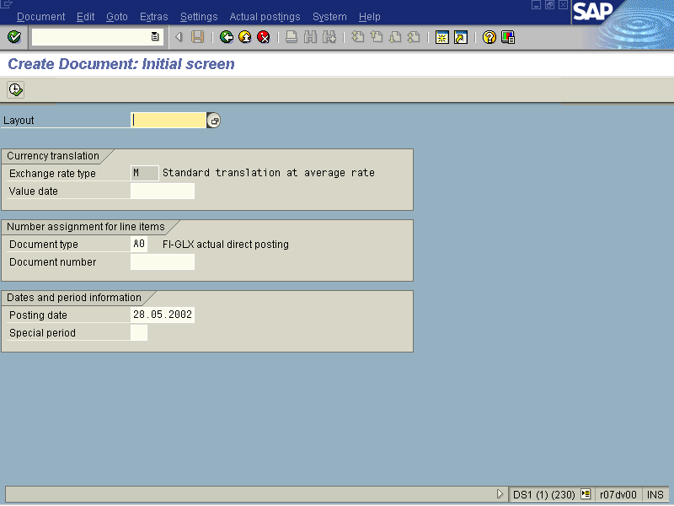

2. Click Layout Button .

Form (1) 10 Entries found

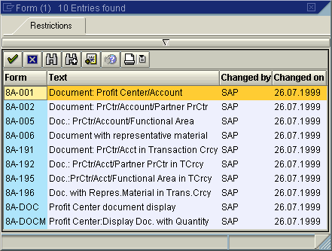

3. Select 8A-001 - Document: Profit Center/Account - SAP - 26.07.1999 in list box.

Create Document: Initial screen

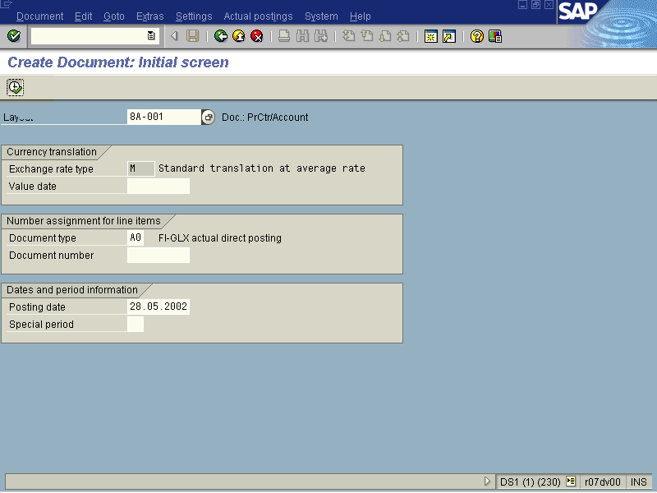

Note: Do NOT change any of the other fields.

4. Click Execute Button .

Create Document: Characteristics

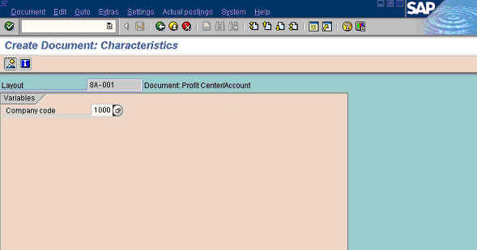

5. Update the following fields:

Field Name | Field Description | Values
Company code | Code identifying the company | Example: 1000 or 5200

6. Click Enter .
7. Click Overview Button .

Create Document: Line items

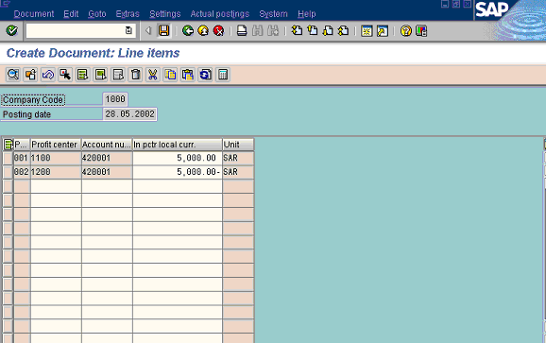

8. Update the following fields:

Field Name | Field Description | Values
Profit center | Code identifying an organizational object for which an independent operating profit is calculated | Example: 1100
Account number | Description of the Account number.... | Example: 420001
In pctr local curr. | Amount in profit center currency | Example: +5000
Profit center | Code identifying an organizational object for which an independent operating profit is calculated | Example: 1200
Account number | Code identifying the General Ledger, Vendor, or Customer account | Example: 420001
In pctr local curr. | Amount in document currency. A negative will denote a credit entry. | Example: -5000

9. Click Enter to validate the information.
10. Click Save button.

Create Document: Characteristics

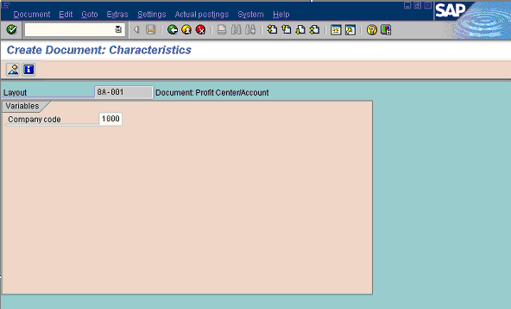

11. The message bar displays “000002 data records were posted in document XXXXXx”

